# Clean and Validate data

* Change Employee_id(eeid) to text also hire date and exit date to date
* Validate date by adjust certain range between 1/1/1992 and 1/1/2023, I did this by data validation
* Remove Duplicate Employee id ,I removed row without hiredate



* Gender column changed to be F or M by =UPPER(LEFT(F2,1))
* Put Dropdown on Gender to avoid any possible errors
* Remove illogical age values like 16,10 and 130.
* 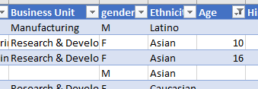

Also I added column named it today with current day to calculate Experience years for each employee

# Some Insights

* How many employees are available in each department r?
* Classify the employees with respect to gender as well as their respective Experience years?
* Classify the employees with respect to their job title and their Salaries?
* List out the employee Ethnicity in each department and classify them with respect to count of them ?
* How many employees Exit and classify them with respect to their gender and salaries rating?
* Top countries with employment
* Top categories of business units and experience years that get bonus.